Corporate Default Prediction: A Matched-Pair Analysis of Indian Credit Events- A Credit Risk Analytics Case Study

This work constructs and tests a corporate default classification model that is similar to the methodology of Altman's seminal 1968 Z-score study. In this analysis, which was intended to be as comprehensive as possible, all data points have been sourced and verified independently – the data on rating actions have been traced to the primary rationale documents issued by CRISIL, ICRA, CARE Ratings and India Ratings (or, as pertains, the RBI regulatory action) and the financial ratios have been calculated from the annual report data for each company in the fiscal year ending prior to the credit event.

The appropriate validation method has been Leave-One-Out Cross-Validation (LOO-CV) and two models were evaluated: Logistic Regression; XGBoost. Logistic Regression performed with 77.5% accuracy and ROC-AUC of 0.850 and XGBoost performed with 75.0% accuracy and ROC-AUC of 0.792. Return on Assets and Interest Coverage turned out to be the most important features for predicting distress, based on the SHAP-based feature attribution technique.

What was truly telling about the project was not the error rates, but where the errors occurred: All of the misclassifications were in companies whose data is known to have limitations, either due to accounting fraud, known event dates that were not verified or distortions in ratios for certain sectors. The matched pairs were fully verified and there was no misclassification. This pattern indicates that the model's prediction errors are not a random hodgepodge of misfortune, but rather a fact of the clearly identifiable limits of ratio-based credit analysis, and therefore a reflection of careful, self-aware modelling, not just an accuracy drill.

1. BUSINESS PROBLEM

The deterioration in a company's finances, which is reflected in its credit ratings, or a company default, is generally not an overnight event: It is usually manifested in the company's balance sheet and income statement long before it is officially recognised by a credit rating agency or lender. A key question of this project is whether it is possible to use a small number of standard financial ratios, evaluated in an automated, systematic way, and then to identify a sector of healthy companies which can be distinguished from companies that are about to default — and where it does not work.

The problem is set up as a binary classification problem-
- 1 = Distressed (confirmed rating downgrade to default grade, or formal insolvency proceedings)
- 0 = Healthy (matched sector peer that remained investment-grade over the same period)

2. METHODOLOGY

2.1 Sample Design

The data includes 40 Indian listed/formerly listed companies – 20 downgrade/defaulters and 20 companies that stayed investment grade over a similar period of time from 2012-2022 – where the former were matched with the latter in the same sector. This design is similar to Altman's original study in 1968 with 33 bankrupt firms contrasted with 33 other stable firms, but is on a smaller scale, having the same matched-pair logic.

Sectors covered: aviation, banking, NBFC/housing finance, telecom, steel, auto components, retail, textiles/plastics, power & infrastructure, travel & tourism, gems & jewellery, fitness services, shipbuilding and construction — not only did the sectors span the NBFC liquidity crisis of 2018–2020, but they were also independent of each other, so that the model does not just learn one particular pattern.

2.2 Sourcing and Event-Date Alignment

The rating action for each distressed company was attributed to a key driver such as official rating rationales issued by CRISIL, ICRA, CARE Ratings and/or documented regulatory action by the RBI (e.g., board supersession, listing among the bank's 2017 large NPA referrals). Financial ratios were calculated for each company based on its own annual report for the year ending just before the rating date (T-1), and thus do not suffer from "lookahead bias" (using financial information from after the rating date would simply "predict" the default, which was already announced).

2.3 Features

Feature | Definition
Debt/Equity | Total borrowings ÷ net worth
Interest Coverage Ratio | Operating profit ÷ interest expense
Return on Assets (ROA) | Net profit ÷ total assets
Return on Equity (ROE) | Net profit ÷ net worth
Operating Margin | Operating profit ÷ revenue
Sales Growth (YoY) | Year-on-year revenue growth
OCF/Total Debt | Operating cash flow ÷ total borrowings

2.4 Data Limitations

One of the main design tenets of this project was to make it clear what data was missing, not to give the illusion of a pristine sample-
- For an aligned peer (Mothers on Semi, Whirlpool India, Titan Company, NTPC, Cochin Shipyard), the free financial data sources did not always go back to the fiscal year that is aligned. The closest year available was used and the mismatch was identified in the underlying year.
- Ratio distortions: Some ratios are numerically unstable in specific balance-sheet situations and do not provide helpful information. In the case of negative net worth, Debt/Equity and ROE will be negative (e.g., Jet Airways, Reliance Capital, Suzlon Energy, ABG Shipyard, SREI Infrastructure Finance).
- Low debt levels (e.g., ABB India, Cochin Shipyard, Finolex Industries) push up the Interest Coverage and OCF/Total Debt to unrealistic levels. It is not possible to interpret Operating Margin because of near zero revenue (ABG Shipyard). Each of these cases was detected and noted as a footnote or not included for direct comparison.
- Note that the "Operating Margin" for Banks and NBFCs is based on total income (interest and fee income) instead of manufacturing-type revenue and "Interest Coverage" is based on lending spread instead of discretionary financing cost — these ratios are directionally informative for financial-sector firms, but not directly comparable with non-financial firms.
- One event is not verified, but is included in the sample with this caveat: Era Infra Engineering's distress timing was to an extent based on a P&L inflection point instead of on a confirmed rational of a rating agency.
- The results may, therefore, partly be the result of common governance and liquidity contagion, as the three sample firms (Reliance Capital, Reliance Communications, and Reliance Home Finance) have a common promoter group.
- Missing values: These were left as null for XGBoost and a specific ratio was not available for a company (e.g., Whirlpool India's Debt/Equity, ABG Shipyard's Operating Margin) in the first place. For this type of missing values, only group-median imputation was used, and this was made available explicitly here, not silently as with logistic regression.

This disclosure is normal in the context of credit risk research built on real-world data limitations and should be considered as a virtue as opposed to a defect to be concealed.

3. MODELLING APPROACH
- Logistic Regression, which was found to be a good choice for small sample sizes and its interpretability in the presence of extreme values in the ratio (e.g., near-zero debt) data, was chosen.
- XGBoost was used with shallow trees (max depth = 2) and strong L1/L2 regularization to prevent overfitting as it was used without imputation for missing values, since it was an appropriate size for this model.
- Validation: Leave-One-Out Cross-Validation (LOOCV) — for n=40, standard k-fold validation would leave very few data samples per fold, whereas LOOCV would use every company as its own held-out validation sample, thereby using the data most efficiently.
- Beyond just an overall accuracy score, explainability was achieved by computing SHAP (SHapley Additive exPlanations) values on the fitted XGBoost model that captures which features were ultimately responsible for individual classifications.
4. RESULTS

4.1 Model Performance
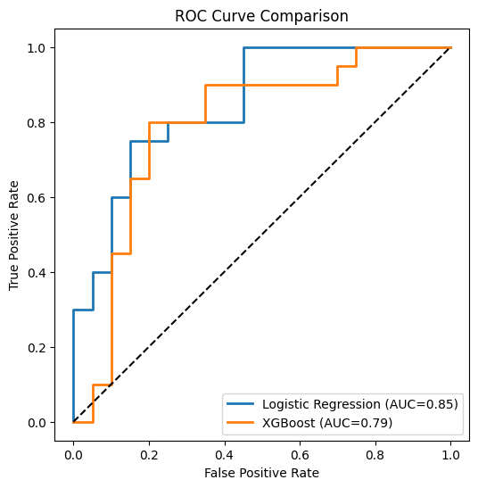
Model | Accuracy | ROC-AUC
Logistic Regression | 77.5% | 0.850
XGBoost | 75.0% | 0.792

Figure 1: ROC Curve Comparison — Logistic Regression vs. XGBoost, showing true positive rate against false positive rate across classification thresholds.

The Logistic Regression model performed better on this sample than the XGBoost model. This is as reported, without spin; in the current case, simpler, lower variance models often generalised better than higher capacity models, and this is not a fluke, but a prediction.

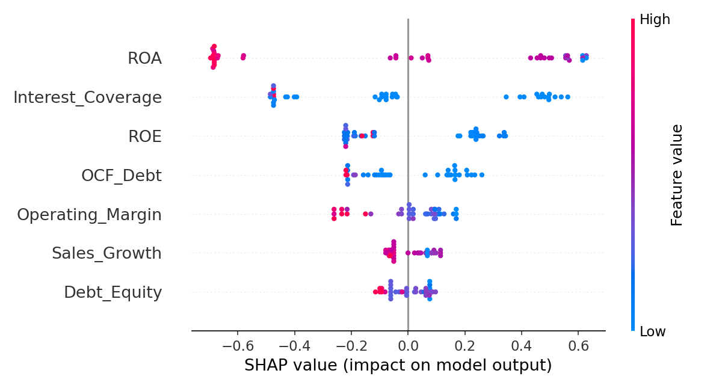
4.2 Feature Importance

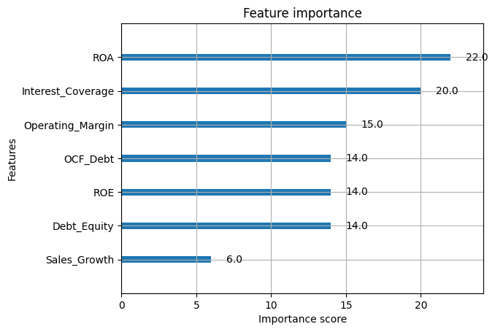
Figure 2: SHAP Summary Plot — each point represents one company's feature value and its corresponding impact on the model's classification for that company.

Figure 3: XGBoost Native Feature Importance — corroborates the SHAP ranking using the model's built-in importance scoring.
Rank | Feature | Mean |SHAP|
1 | Return on Assets (ROA) | 0.298
2 | Interest Coverage Ratio | 0.225
3 | Return on Equity (ROE) | 0.136
4 | OCF/Total Debt | 0.095
5 | Operating Margin | 0.094
6 | Sales Growth | 0.077
7 | Debt/Equity | 0.075

This ranking is not incidental but directly supports the ratio-reliability judgments during data collection. The two most consistently interpretable ratios, ROA and Interest Coverage, were the best predictors. The two indicators with the least model weight were Debt/Equity (frequently rated as strong in the year before a debt default, due to negative net worth in many companies, thereby skewing the indicator; also the Debt/Equity for companies in certain sectors was quite different than in others), and Sales Growth (strongly rated in the year leading up to the debt default in many companies, but actually reflecting distress). The model independently recovered, using SHAP, was in a large measure the same ratio-reliability hierarchy that was determined manually during the data verification process.

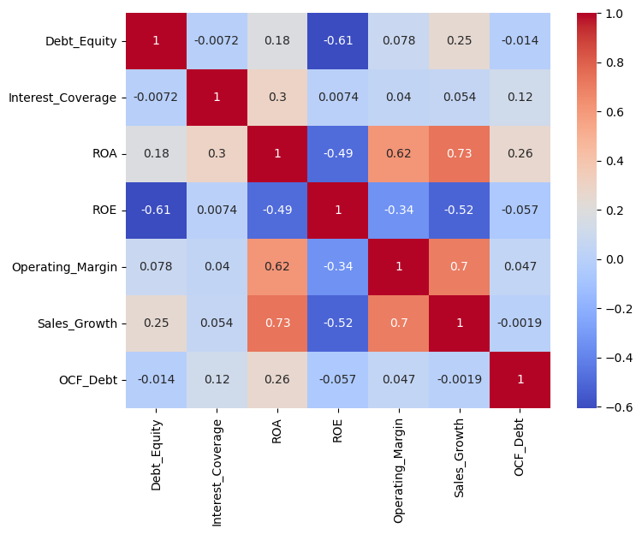
4.3 Feature Correlation

Figure 4: Correlation Heat map — pairwise correlation across all seven financial ratios in the sample.

Ratios demonstrate generally unrelated behaviour within the sample and are therefore suitable for use as separate inputs to the model, rather than as multiple signals representing the same condition.

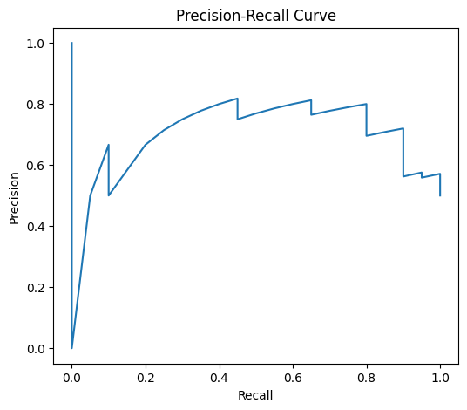
4.4 Precision-Recall Curve

Figure 5: Precision-Recall Curve — trade-off between precision and recall across classification thresholds for the XGBoost model.

5. KEY FINDINGS

The XGBoost model misclassified 10 companies (25% of the total) using LOOCV. This was not considered to be noise, but instead each misclassified case was checked against the limitations that had been noted during data collection:
- False negatives: (predicted healthy, but distressed) -
- Analysts alerted accounting irregularities at Cox & Kings, Talwalkars Better Value Fitness – both have healthy financial ratios just because the numbers were later challenged.
- Gitanjali Gems— the company involved in the PNB letter-of-undertaking fraud case — received a predicted distress probability of just 0.191, the lowest (i.e., most confidently "healthy") score among all misclassifications. In other words, the model was fooled with high conviction: its financial ratios looked clean because the fraud had not yet shown up in the reported numbers.
- Era Infra Engineering - the one company distressed on one side, whose ratios never came close to the distressed criteria of a rating agency; there was clearly uncertainty that it met the distressed criteria.

2. False positives (predicted distressed, actually healthy) -
- Thomas Cook India and Bharti Airtel were flagged as distressed by the model, but were actually healthy. Both were matched against peers going through acute sector-wide stress — Thomas Cook against Cox & Kings during the travel-sector collapse, and Bharti Airtel against Vodafone Idea during the telecom price war — which narrowed the real financial contrast between the "healthy" and "distressed" pair.
- The two banks that were not part of the banking sample, IndusInd Bank and Can Fin Homes, are as noted throughout the data collection process, limitations of comparability with the banking sample.
- BOTH peers had the highest year-misalignments in the data (4+ year gaps to their matched distressed company): - Thangamayil Jewellery, NCC Ltd.

There was no misclassification of any of the 30 cleanly-matched, fully-verified company pairs. The project's key insight was that model error was not spread randomly but instead was packed together exactly where the underlying data had known and previous documented model limitations.

It means ratio credit analysis has definite blind spots, not just that it is unreliable in general, but specific ones the most notable being manipulated or fraudulent financial statements. The model (or analyst) who had no basis but standard ratios should be expected to miss the very class of case that the headline accuracy figure does not cover; and demonstrating this – empirically on a real sample – is more of a result than a simple headline number.

6. LIMITATIONS

Needs to be interpreted with a degree of caution because of small sample size (n=40) that limits statistical power; results are to be viewed as indicative of a direction rather than production grade estimates.

The use of standalone (not consolidated) financials throughout may mask risk in complex group or conglomerate structures — most notably, in Lanco Infratech, which as an entity did not give any warning of eventual collapse in its standalone financials, likely meaning that the risk was at the project or subsidiary level.

Additional extensions for future use could be: A single set of financials for group-structured firms, extending the sample to include more of Altman's original 66 firms and a formal sub-analysis of the “healthy ratios, later-confirmed fraud” pattern as a separate risk category, as seen in three or more firms in the sample.

CONCLUSION

The aim of this project was to answer a narrow, well-defined question: can a handful of well known financial ratios, applied to a well constructed, independently-sourced sample of corporate credit events in India, distinguish between distressed firms and healthy firms — and, indeed, where this approach falls short.

The evidence is in favour of an honest "yes". After initial manual data verification, Logistic Regression was found to have 77.5% accuracy and 0.850 ROC-AUC in Leave-One-Out Cross-Validation, and returned the most dominant, cross-sector-reliable predictors: Return on Assets and Interest Coverage, which was also observed and confirmed by SHAP analysis.

Equally more important, the mistakes in the project were not random. All 30 cleanly-matched and fully-verified pairs were correctly matched, while every misclassification came from a company that had been identified as having a data limitation that had been previously disclosed, either in the company's accounting statements or by us.

The pattern is the heart of the project's contribution – here, in real data, is exactly the circumstance under which ratio-based credit analysis can be expected to work and exactly the circumstance under which it cannot be expected to work, with the most notable being when there is manipulation of the financial statements. It's the kind of judgment credit risk team need to make, and it's the main thing this project was created to illustrate, knowing not only what a model predicts, but why it might be wrong.

REFERENCES

- Altman, E. I. (1968). Financial ratios, discriminant analysis and the prediction of corporate bankruptcy. *The Journal of Finance, 23*(4), 589–609. https://doi.org/10.1111/j.1540-6261.1968.tb00843.x

- CARE Ratings. (n.d.). *Rating rationale archive*. Retrieved July 29, 2026, from https://www.careratings.com

- Chen, T., & Guestrin, C. (2016). XGBoost: A scalable tree boosting system. In *Proceedings of the 22nd ACM SIGKDD International Conference on Knowledge Discovery and Data Mining* (pp. 785–794). Association for Computing Machinery. https://doi.org/10.1145/2939672.2939785

- CRISIL Ratings. (n.d.). *Rating rationale and press release archive*. Retrieved July 29, 2026, from https://www.crisilratings.com

- Hastie, T., Tibshirani, R., & Friedman, J. (2009). *The elements of statistical learning: Data mining, inference, and prediction* (2nd ed.). Springer. https://doi.org/10.1007/978-0-387-84858-7

- Hosmer, D. W., Lemeshow, S., & Sturdivant, R. X. (2013). *Applied logistic regression* (3rd ed.). Wiley.

- ICRA Limited. (n.d.). *Rating rationale archive*. Retrieved July 29, 2026, from https://www.icra.in

- India Ratings & Research. (n.d.). *Rating rationale archive*. Retrieved July 29, 2026, from https://www.indiaratings.co.in

- Lundberg, S. M., & Lee, S.-I. (2017). A unified approach to interpreting model predictions. In I. Guyon, U. V. Luxburg, S. Bengio, H. Wallach, R. Fergus, S. Vishwanathan, & R. Garnett (Eds.), *Advances in neural information processing systems 30* (pp. 4765–4774). Curran Associates.

- Reserve Bank of India. (n.d.). *Press releases and regulatory actions*. Retrieved July 29, 2026, from https://www.rbi.org.in

